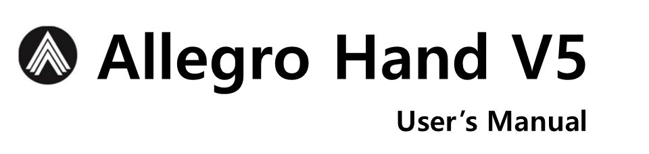

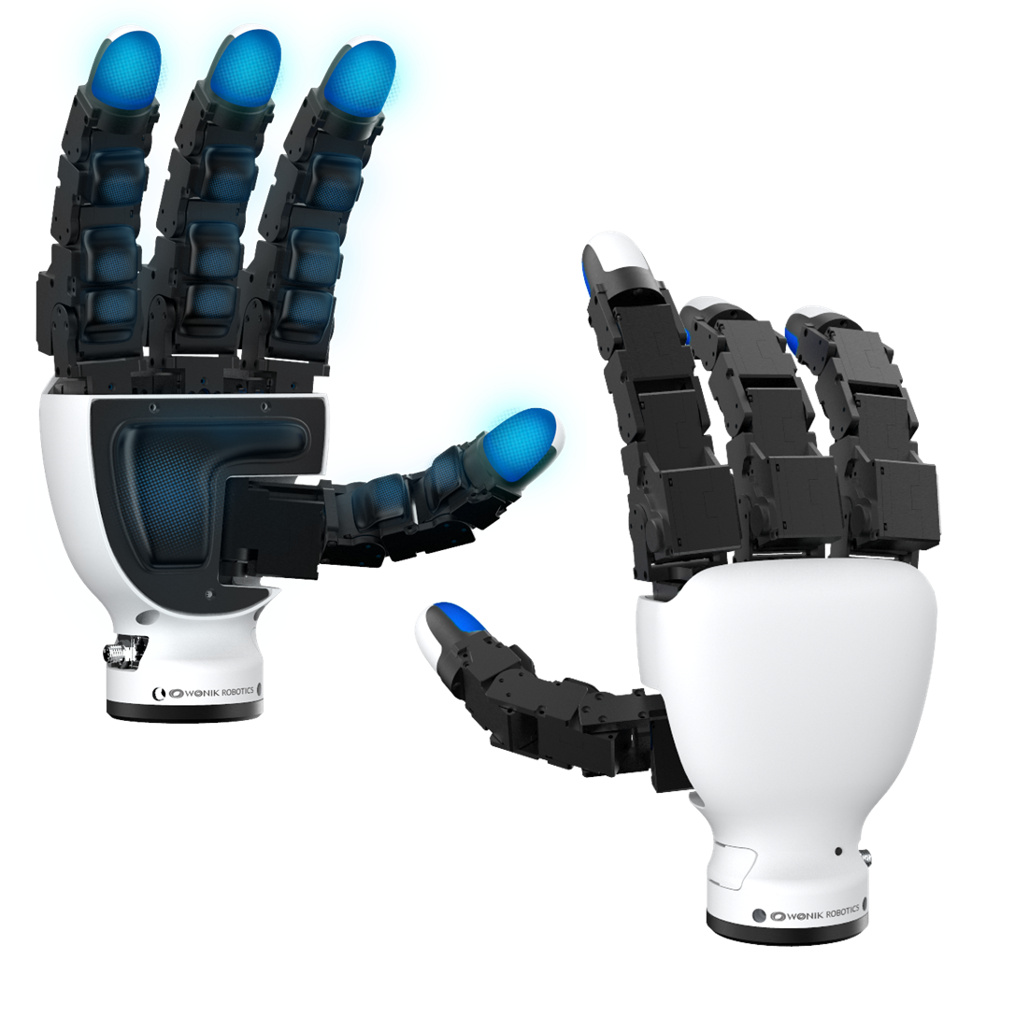



Allegro Hand V5 Sense User’s Manual
Copyright © WONIK ROBOTICS

Copyright & Trademark Notice
Allegro, the Allegro logo and all related files and documentation are Copyright by WONIK ROBOTICS. All rights reserved.

Allegro, Allegro Hand is trademarks of WONIK ROBOTICS. All other trademarks or registered trademarks are the property of their respective owners.

Contents
Copyright & Trademark Noice i
1. Quick Start Guide 1
1.1 In the Box 1
1.2 Power Supply 1
1.3 CAN Device 1
2. Allegro Hand Overview 2
3. Technical Specifications 3
4. System Requirements 5
5. Joint Dimensions 6
6. Joint Directions 7
6.1 Right Hand 7
6.2 Left Hand 7
7. Mounting the Allegro Hand 8
7.1 Mounting Block Removal 8
7.2 Mounting 9
7.3 Reassembly 9
7.4 Mount Block Dimensions 10
8. Allegro Hand Wiring 11
8.1 Wiring 12
8.2 Power 12
9. CAN Driver Installation 13
9.1 PEAK PCAN-USB 13
10. CAN Protocol 13
10.1 Baud-Rate 13
10.2 Periodic Communication 13
10.3 Control Modes 13
11. CAN Frames 15
11.1 Arbitration Identifier 15
11.2 Message ID 15
11.3 Data Structure 16
11.3.1 Servo ON 16
11.3.2 Servo Off 16
11.3.3 Set Torque Finger 16
11.3.4 Information 16
11.3.5 Serial Number Read 17
11.3.6 Position Finger 17
11.3.7 Current Finger 17
11.3.8 Pressure Sensor 18
11.3.9 Position Calibration 19
11.3.10 Error 19
11.3.11 Set Pose Direct Finger 20
11.3.12 H-inf Mode 21
11.3.13 Gravity Feed Forward 21
12. UDP Protocol 23
12.1 Switch Communication Mode 23
12.2 Transport and Port 23
12.3 Packet Header 23
12.4 Packet 24
12.5 Payload Structures 25
12.5.1 Telemetry_raw 25
12.5.2 Torque_cmd 25
12.5.3 Hello_resp 25
12.5.4 Motor_error 25
12.5.5 GFF_RPY_req 25
13. Using Allegro Hand Sample Program 27
13.1 Download Sample Program 27
13.2 BHand Library 27
13.2.1 Home 27
13.2.2 Grasp 3 27
13.2.3 Grasp 4 27
13.2.4 Pinching(I) 28
13.2.5 Pinching(M) 28
13.2.6 Envelop 28
13.2.7 Gravity Compensation 29
13.2.8 Power Off 29
13.3 ROS Program 29
13.3.1 Rviz 29
13.3.2 Control with GUI 29
13.3.3 H-inf Onboard Position Control Mode 30
14. Firmware Update 32
14.1 Download Firmware Image 32
14.2 Update Firmware Image to Allegro Hand 32
14.2.1 Connect to Allegro Hand 32
14.2.2 Run the Application 33
15. Technical Support 35
16. FAQ 36
16.1 Hardware FAQ 36
16.2 Software FAQ 39

1. Quick Start Guide
1.1 In the Box
Included are the software and hardware necessary to get you started.
- Allegro Hand 1 EA
- Allegro Hand Case 1 EA
- Power and Communication Cable (8 pin) 1 EA
- Desktop Stand 1 EA
- AC/DC Power Adapter 1 EA

1.2 CAN Device
We usually recommend the PEAK device.
Model: PCAN-USB (IPEH-002021 or IPEH-002022)
Wonik Robotics does not sell CAN equipment.

2. Allegro Hand Overview
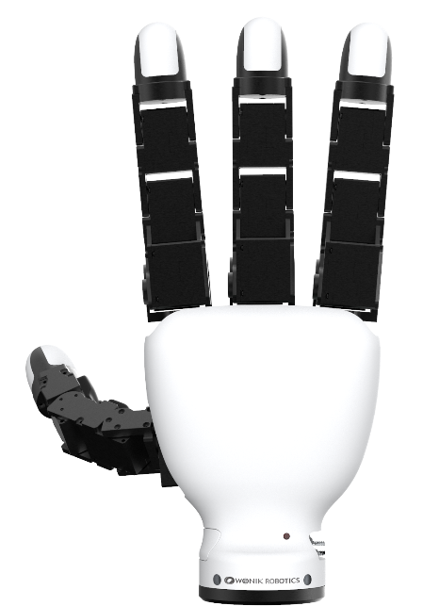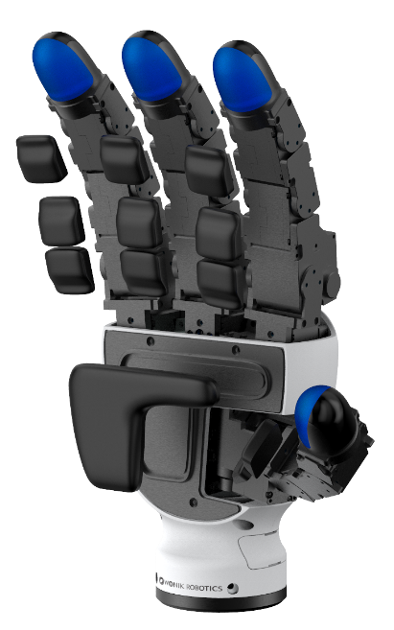
Allegro Hand is a highly adaptive robotic hand.
With four fingers and sixteen independent current-controlled joints and tactile sensors, it’s the perfect platform for grasp and manipulation research.

Features
- Lightweight and portable anthropomorphic design
- Provides adduction and abduction capability of the fingers, enabling more natural and versatile grasping similar to a human hand
- Multiple ready-to-use grasping algorithms capable of handling a variety of object geometries
- 16 independent current-controlled joints (4 fingers x 4 DOF ea.)
- Equipped with 16 pressure sensing channels (4 fingertips, 11 joints, and 1 palm) to capture detailed force distribution for precise tactile feedback
- Support for real-time control and online simulation

3. Technical Specifications
Number of Fingers | 3 fingers + 1 thumb = 4
Degrees of Freedom | 4 fingers x 4 = 16 (active)
Actuation | Type | DC motor
Actuation | Gear Ratio | 288.35:1  576.7:1, 2nd joint of the finger excluding the thumb
Actuation | Stall Torque | 0.92 Nm  1.84 Nm, 2nd joint of the finger excluding the thumb
Actuation | Nominal Torque | 0.23 Nm  (Plus: 0.46 Nm, 2nd joint of the finger excluding the thumb)
Payload | Max. 15kg
Weight | 1,240g
Joint Resolution | 0.088 deg
Communication | Type | CAN, Ethernet (UDP)
Communication | Frequency | 333 Hz
Power Requirement | 24.0 V / 5.0 A / 120 W
Tactile Sensor  *Pressure Sensor | Pressure Operating Range | Returns '0' at atmospheric pressure (101.3 kPa)  0~400 kPa
Tactile Sensor  *Pressure Sensor | Color Indicator  (Fingertips only) | Blue: 0~5 kPa  Cyan: 5~10 kPa  Green: 10~20 kPa  Yellow: 20~30 kPa  Red: 30~400 kPa
Tactile Sensor  *Pressure Sensor | Temperature Operating Range | 0~60 ℃
Tactile Sensor  *Pressure Sensor | Pressure Accuracy | 0.1 kPa

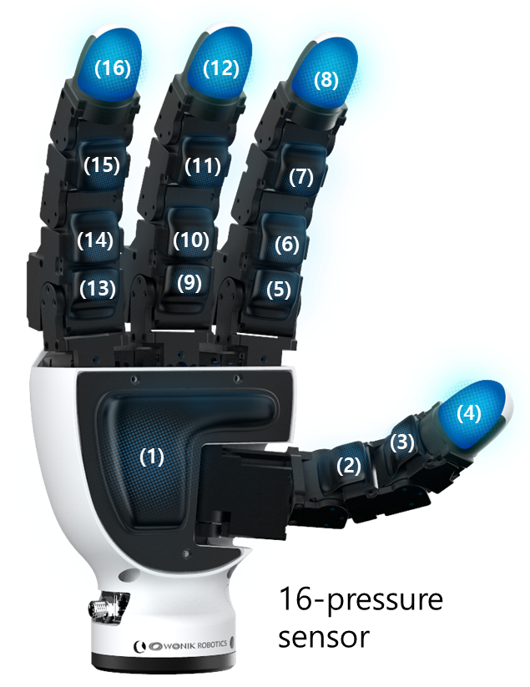
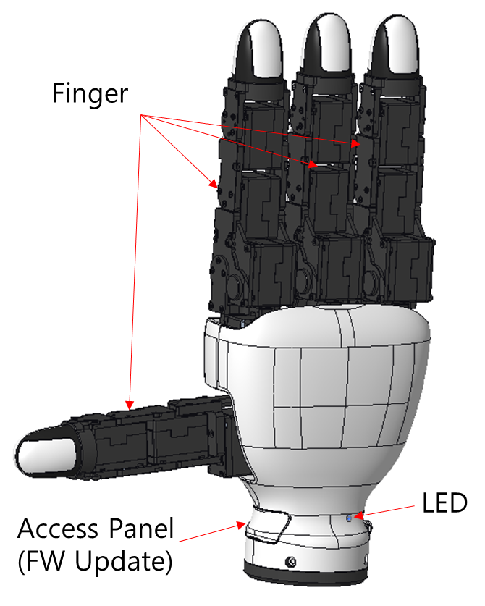
4. System Requirement
CPU | Intel® CoreTM i3-8109U or higher
RAM | at least 2GB
Storage | at least 2GB
Graphics | OpenGL 3.0 H/W Acceleration enabled with at least 64Mb of video RAM
OS | Ubuntu® 22.04 LTS & 24.04 LTS
Additional S/W | ROS2

5. Joint Dimensions
All dimensions are displayed in millimeters (mm) and degrees.
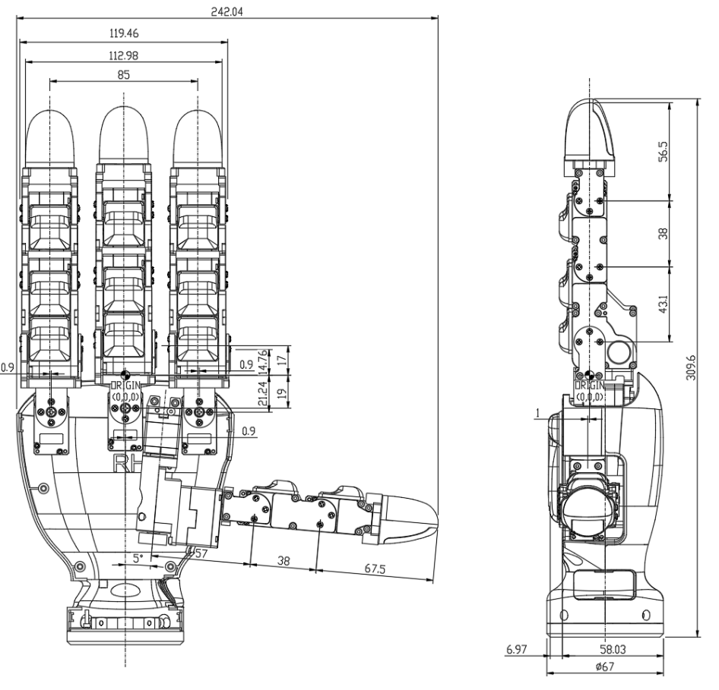
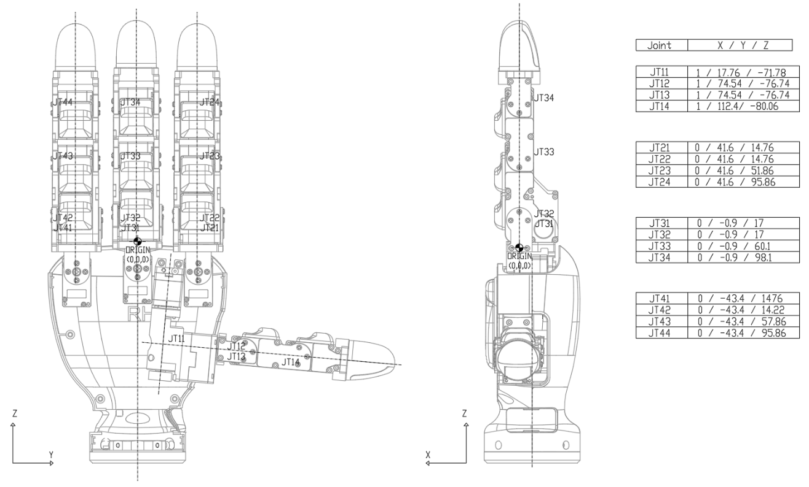
6. Joint Directions
6.1 Right Hand
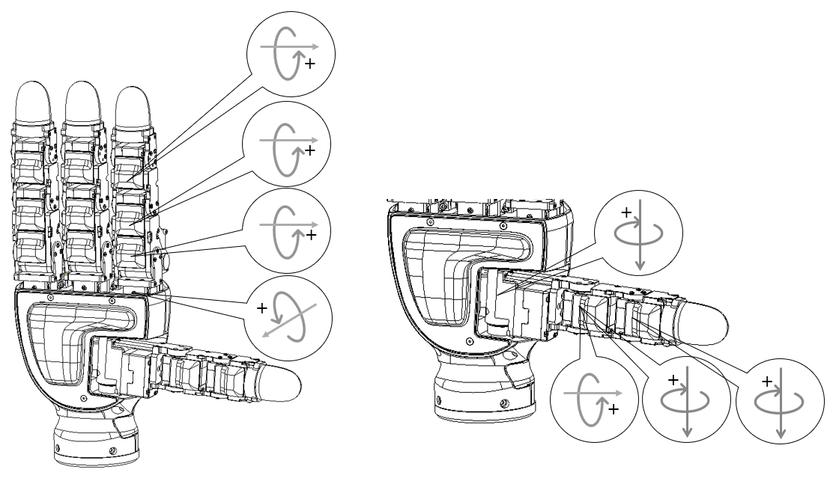

6.2 Left Hand
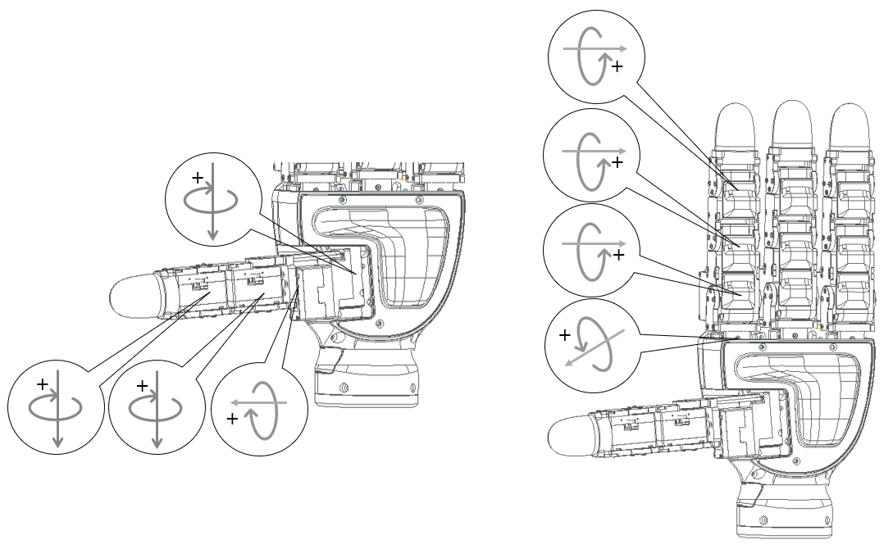
7. Mounting the Allegro Hand
All dimensions are displayed in millimeters (mm) and degrees.

7.1 Mounting Block Removal
The mounting block is connected to the Allegro Hand using four M3x10mm hex socket head cap screws. Once the 4 screws have been removed, the mounting block can be removed from the bottom of the hand
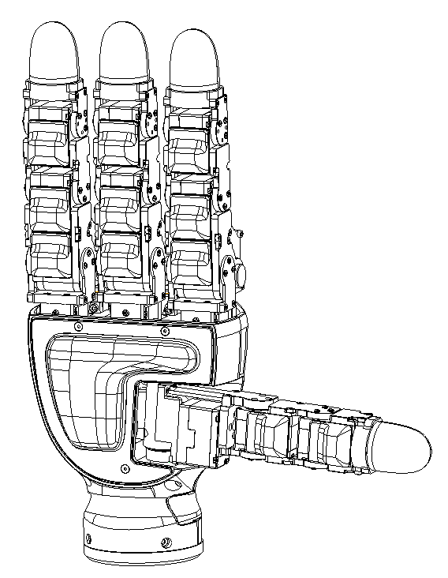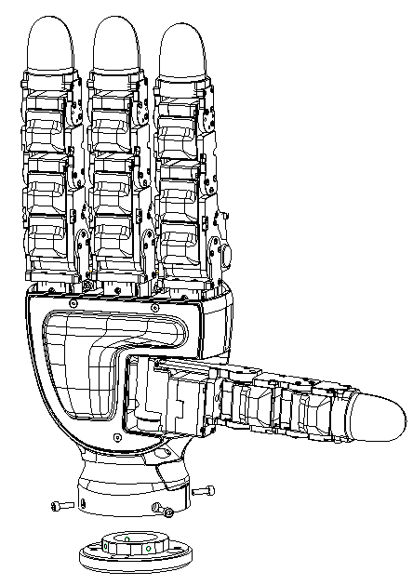
.

7.2 Mounting
The block can be mounted to the manipulator's end effector using four M6x10mm hex socket head cap screws.
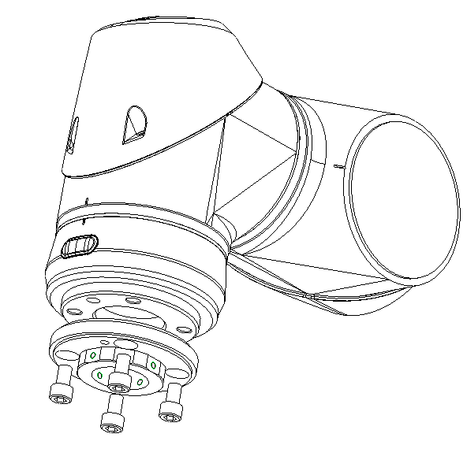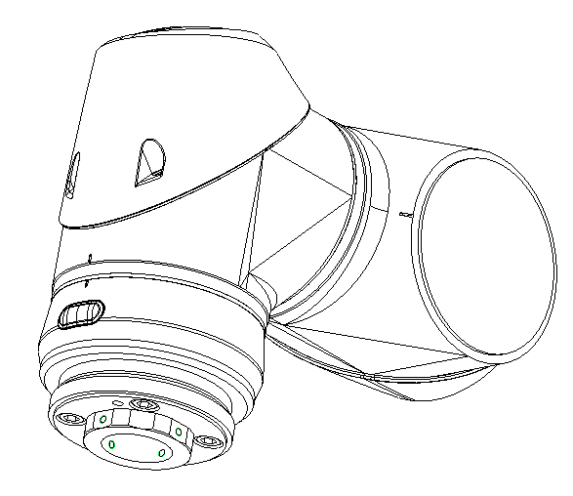
When changing the hand's orientation, please use a alternator bracket; please follow the instructions below.

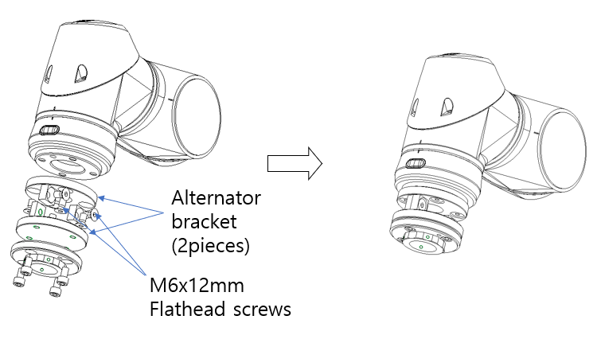
7.3 Reassembly
Place the hand onto the mounting block and replace the three M3x10mm hex socket head cap screws.
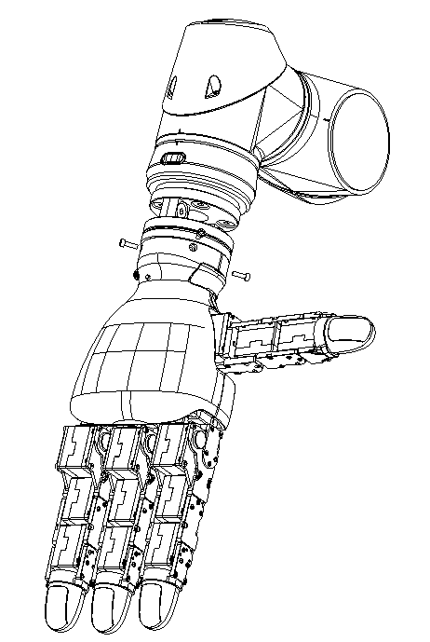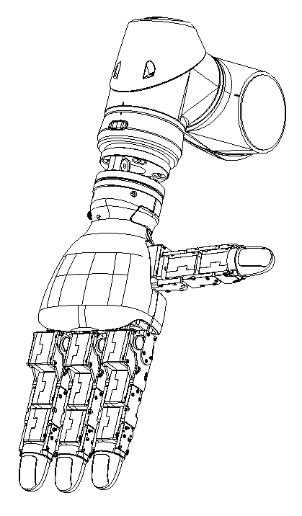
7.4 Mounting Block Dimensions
The relevant dimensions of the mounting block are presented in millimeters (mm).
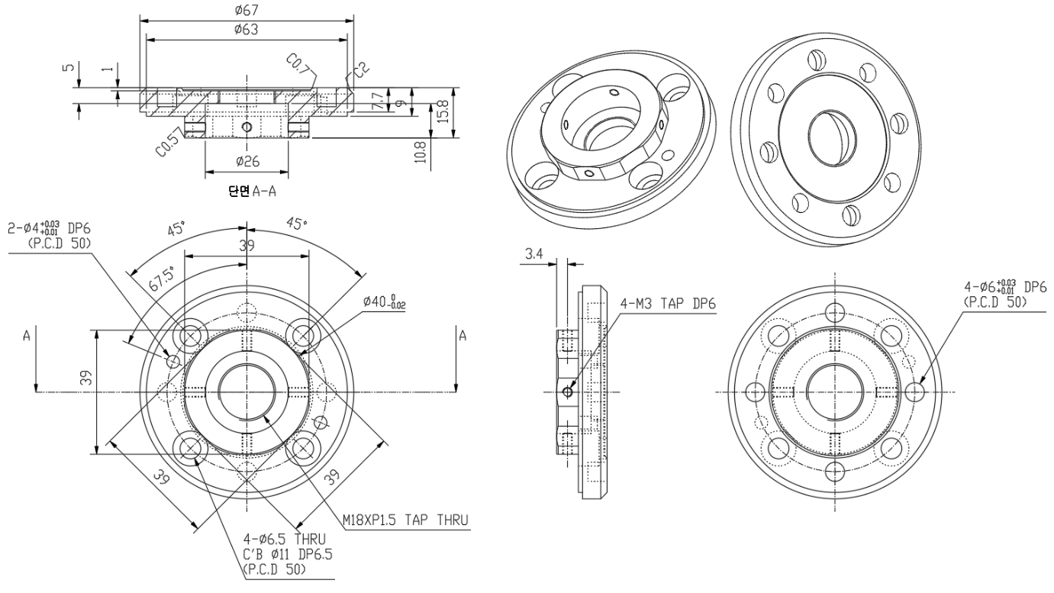

8. Allegro Hand Wiring
8.1 Wiring
On the back of the Allegro Hand, you will see a connector. This connector is used to supply power to hand. It also has external interface. Connector used is MB08MSAFF08ST part.
 | Part Name | Note
Panel Mount Connector | MB08MSAFF08ST | M8 Stecker 8P, A-coding
Cable Connector |  | M8-F-Angle-8P-3m

Connector Pinout
No. | Description | Wiring Color
1 | N/A | White
2 | N/A | Brown
3 | CAN L | Green
4 | CAN H | Yellow
5 | 24VDC_in | Gray
6 | GND | Pink
7 | 24VDC_in | Blue
8 | GND | Red

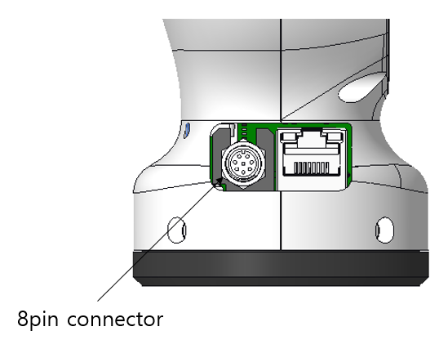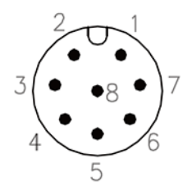
8.2 Power
The Allegro Hand must be powered by DC 24V, 5A power supply. If a capacity of power supply is not sufficient, it will not work properly.
Once the power is supplied at the rated values, the power switch on the back of the Allegro Hand can be switched on to provide power to the hand.

9. CAN Driver Installation
9.1 PEAK PCAN-USB (Drivers available for Windows and Linux)

PEAK PCAN-USB
Product Page: http://www.peak-system.com/PCAN-USB.199.0.html?&L=1

Note: PEAK PCAN-USB can be purchased through WONIK ROBOTICS.

10. CAN Protocol
The Allegro Hand designed with CAN specification 2.0.
10.1 Baud-Rate
The CAN communication baud-rate is 1Mbps.

10.2 Periodic Communication
The Allegro Hand control software attempts to communicate with the Allegro Hand at a regular control interval. Every 3 milliseconds, the join torques are calculated and the joint angles are updated.
10.3 Control Modes
The Allegro Hand supports two control modes, selectable at runtime:
(1) Torque Control Mode (Default): The host PC computes desired joint torques using the BHand library or a custom controller and sends them to the hand via the Set Torque Finger commands (logical ID 0x060–0x063) every 3 ms. The firmware acts as a current-controlled actuator; all position control loops run on the host side.
(2) H-infinity Onboard Position Control Mode: The firmware runs an H-infinity position controller internally. The host sends desired joint angles (as encoder counts) via the Set Pose Direct commands (logical ID 0x060–0x063). The firmware closes the position loop at its own internal rate. This mode must be activated by sending the H-inf Mode command (ID 0x228) with data[0] = 1 before sending position targets. To return to Torque Control Mode, send the H-inf Mode command with data[0] = 0.
Note: The Set Torque Finger and Set Pose Direct commands share the same logical CAN IDs (0x060–0x063). The firmware disambiguates them based on the currently active control mode.

11. CAN Frames
11.1 Arbitration Identifier
The Allegro Hand uses 11-bit standard arbitration identifier.
MAB | 9 | 8 | 7 | 6 | 5 | 4 | 3 | 2 | 1 | LSB
Message ID |  |  |  |  |  |  |  |  | 0 | 0

11.2 Message ID
Message | Message ID | RTR | Description
Servo ON | 0x040 |  | Engage joint motor driver
Servo OFF | 0x041 |  | Disable joint motor driver
Set Torque Finger 1 | 0x060 |  | Set torque of finger #1
Set Torque Finger 2 | 0x061 |  | Set torque of finger #2
Set Torque Finger 3 | 0x062 |  | Set torque of finger #3
Set Torque Finger 4 | 0x063 |  | Set torque of finger #4
Information | 0x080 | R | Product information and status
Serial Number Read | 0x088 | R | Product serial number read
Position Calibration | 0x089 |  | Start position calibration  (sets all encoders to 0(Joint 13 : 90)
Finger Current 1 | 0x000 | R | Current motor current of finger #1 & #2
Finger Current 2 | 0x003 | R | Current motor current of finger #3 & #4
Position Finger 1 | 0x020 | R | Current angle position of finger #1
Position Finger 2 | 0x021 | R | Current angle position of finger #2
Position Finger 3 | 0x022 | R | Current angle position of finger #3
Position Finger 4 | 0x023 | R | Current angle position of finger #4
Pressure Sensor 1 | 0x54 |  | Current pressure of tactile sensors  (Palm & Thumb, Index finger)
Pressure Sensor 2 | 0x55 |  | Current pressure of tactile sensors (Middle, Ring finger)
HINF_MODE | 0x228 |  | Enable (data[0]=1) or Disable (data[0]=0) H-inf onboard position control mode.
GFF_RPY | 0x22C |  | Send Gravity Roll/Pitch/Yaw
Set Pose Direct Finger 1 | 0x060 |  | Set position target of finger #1 (H-inf onboard position control mode)
Set Pose Direct Finger 2 | 0x061 |  | Set position target of finger #2 (H-inf onboard position control mode)
Set Pose Direct Finger 3 | 0x062 |  | Set position target of finger #3 (H-inf onboard position control mode)
Set Pose Direct Finger 4 | 0x063 |  | Set position target of finger #4 (H-inf onboard position control mode)
Error | 0xEE |  | Error

Messages marked with RTR can be sent by host in remote frame, and the Allegro Hand will respond it.

11.3 Data Structure
Each message has different data filed format. All multi-byte data structures in data filed uses little endian.
11.3.1 Servo ON
Data length = 0
This message does not have data field.
11.3.2 Servo OFF
Data length = 0
This message does not have data field.
11.3.3 Set Torque Finger
Data length = 8
Each finger has 4 joints. This message sets joint torque set-point. Torque set-point is 2 byte signed digit. Data field is composed as below.
Torque Data [0:7]
0 | 1 | 2 | 3 | 4 | 5 | 6 | 7
Joint1 |  | Joint2 |  | Joint3 |  | Joint4
11.3.4 Information
Data length = 7
Information message is composed with hardware version and firmware version. The Allegro Hand sends this message when the host request by remote frame.
Information Data [0:6]
0 | 1 | 2 | 3 | 4 | 5 | 6
Hardware Ver. |  | Firmware Ver. |  | 0 | 0 | 1
Hardware Ver. and Firmware Ver. is 2-byte number.
11.3.5 Serial Number Read
Data length = 8
Serial number can be retrieved using CAN interface. It is stored in ASCII characters. The Allegro Hand sends this message when the host request by remote frame.
11.3.6 Position Finger
Data length = 8
Joint position is reported through this message format. The Allegro Hand sends this message when the host request by remote frame or report period comes. All values are represented as signed 2-byte integer.
Position Data [0:7]
0 | 1 | 2 | 3 | 4 | 5 | 6 | 7
Joint1 |  | Joint2 |  | Joint3 |  | Joint4
Joint angle can be calculated by this equation
$$angle\left[rad\right]=\frac{\left(position data\right)*π}{180}*0.088$$
11.3.7 Current Finger
Data length = 8
Motor current is reported through this message format. The Allegro Hand sends this message when the host request by remote frame or report period comes. All values are represented as signed 1-byte integer.
Finger Current 1 (0x000) Data [0:7]
0 | 1 | 2 | 3 | 4 | 5 | 6 | 7
Joint1 | Joint2 | Joint3 | Joint4 | Joint1 | Joint2 | Joint3 | Joint4
Thumb finger |  |  |  | Index finger
Finger Current 4 (0x003) Data [0:7]
0 | 1 | 2 | 3 | 4 | 5 | 6 | 7
Joint1 | Joint2 | Joint3 | Joint4 | Joint1 | Joint2 | Joint3 | Joint4
Middle finger |  |  |  | Ring finger

11.3.8 Pressure Sensor
Data length = 8
Pressure sensor data is reported through this message format. The Allegro Hand sends this message when report period comes. All values are represented as unsigned 1-byte integer.
Finger Current 1 (0x000) Data [0:7]
0 | 1 | 2 | 3 | 4 | 5 | 6 | 7
Sensor1 | Sensor2 | Sensor3 | Sensor4 | Sensor5 | Sensor6 | Sensor7 | Sensor8
Thumb finger |  |  |  | Index finger
Finger Current 4 (0x003) Data [0:7]
0 | 1 | 2 | 3 | 4 | 5 | 6 | 7
Sensor9 | Sensor10 | Sensor11 | Sensor12 | Sensor13 | Sensor14 | Sensor15 | Sensor16
Middle finger |  |  |  | Ring finger

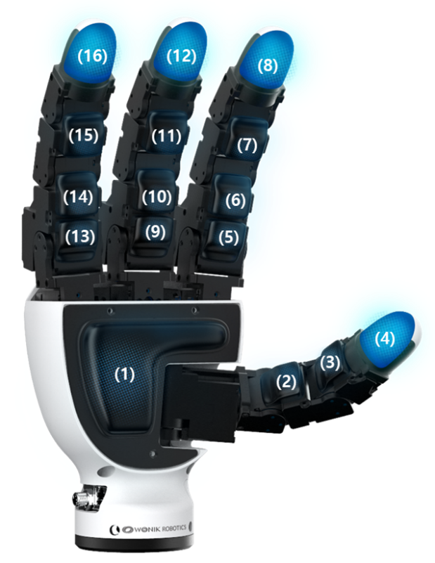
Pressure sensor data is expressed in 0.1kPa units, indicating the pressure applied to the fingertip, finger joint and palm.

11.3.9 Position Calibration
Data length = 0
This message does not have data field. This message instructs the hand to reset all joint encoders to 0.

11.3.10 Error
Data length = 2
Error message is reported through this message format.
Error Data [0:1]
0 | 1
Motor ID | Error code
The error code is displayed as a result of a bitwise OR operation for each situation, and its meaning is as follows.
Bit | Error | Description
7 |  | Always 0
6 |  | Always 0
5 | Overload | A load that cannot be controlled by the motor's maximum output is continuously applied
4 | Electrical Shock | When the circuit experiences an electrical shock or there is insufficient input power, the motor may fail to operate normally
3 |  | Always 0
2 | Overheating | When the motor's temperature exceeds or falls below the set temperature
1 |  | Always 0
0 | Input Voltage | When the applied voltage exceeds or falls below the specified operating voltage range
If an error occurs, the LED on the back of the hand changes from blue to red blink.

11.3.11 Set Pose Direct Finger
Data length = 8
Each finger has 4 joints. This message sets the joint position target in H-inf onboard position control mode. The logical CAN IDs are 0xE0–0xE3. Position set-point is a 2-byte signed integer (encoder count). Data field is composed as below.
Pose Data [0:7]
0 | 1 | 2 | 3 | 4 | 5 | 6 | 7
Joint1 (low) | Joint1 (high) | Joint2 (low) | Joint2 (high) | Joint3 (low) | Joint3 (high) | Joint4 (low) | Joint4 (high)
Joint angle can be converted to encoder count by this equation:
count = round( angle_deg / 0.088 )
or equivalently
count = round( angle_rad × 180 / (π × 0.088) )
Value range: −32768 to 32767. Logical ID 0x060 = Finger 1 (index), 0x061 = Finger 2 (middle), 0x062 = Finger 3 (little), 0x063 = Finger 4 (thumb).

11.3.12 H-inf Mode
Data length = 8 (only data[0] is used)
This message enables or disables H-infinity onboard position control mode in the firmware. Unlike other commands, this message is sent using the raw CAN ID (no logical left-shift). It is recommended to send this command 3 times with 2 ms intervals to ensure reliable delivery during firmware startup.
H-inf Mode Data [0:7]
data[0] | 0 = Disable (return to Torque Control Mode)
data[0] | 1 = Enable (H-inf Onboard Position Control Mode)
data[1..7] | (ignored)

Note: After enabling H-inf Mode, send Set Pose Direct Finger commands (logical ID 0x060–0x063) as position targets. After disabling, resume Set Torque Finger commands on the same logical IDs.

11.3.13 Gravity Feed Forward
Data length = 6
Sets the hand's orientation in the world frame for Gravity Feed-Forward compensation. The orientation is represented as Roll, Pitch, and Yaw in centi-degrees. All values are signed 2-byte integers (Little Endian).

GFF_Roll/Pitch/Yaw Data [0:5]
0 | 1 | 2 | 3 | 4 | 5
Roll |  | Pitch |  | Yaw
12. UDP Protocol
The Allegro Hand V5 Sense supports a UDP-only protocol (port 7000) using a single datagram channel for commands, telemetry, and torque control.
12.1 Switch Communication Mode
Remove the side cover and change switch as shown in the figure below,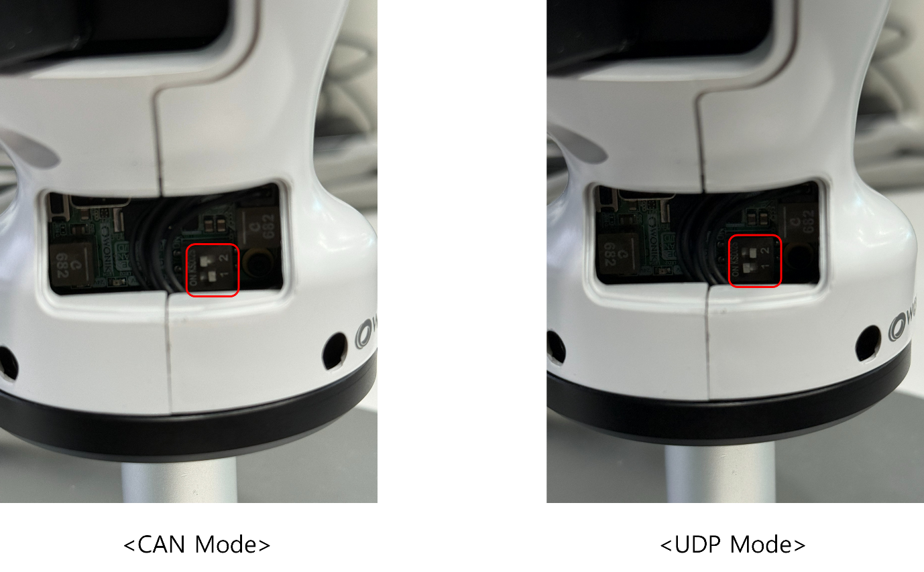
12.2 Transport and Port
- Protocol: UDP
- Port: 7000 (Default for Peer), 8000 (Default for Local)
- Endianness: Little Endian

12.3 Packet Header
Every UDP datagram starts with a 16-byte Packet Header.
Offset | Size (Bytes) | Field | Description
0 | 4 | magic | Frame sync magic word (0x32423556)
4 | 1 | version | Protocol version (0x01)
5 | 1 | type | Packet type ID
6 | 2 | length | Payload length in bytes
8 | 4 | seq | Sequence number
12 | 4 | timestamp_ms | Timestamp in milliseconds

12.4 Packet
Message | Type ID | Direction | Payload Size | Description
TELEMETRY_RAW | 0x02 | FW -> PC | 164 bytes | Periodic state telemetry
TORQUE_CMD | 0x03 | PC -> FW | 32 bytes | Target joint torques
HELLO_REQ | 0x10 | PC -> FW | 0 bytes | Connection request
HELLO_RESP | 0x11 | FW -> PC | 7 bytes | Product information and status
JAC_REQ | 0x20 | PC -> FW | 0 bytes | Request joint angle calibration
CAL_DONE | 0x21 | FW -> PC | 0 bytes | Calibration completion status
SN_READ_REQ | 0x34 | PC -> FW | 0 bytes | Request Serial Number
SN_RESP | 0x35 | FW -> PC | 8 bytes | Hand Serial Number (ASCII)
MOTOR_ERROR | 0x50 | FW -> PC | 2 bytes | Motor error reporting
HINF_MODE | 0x60 | PC -> FW | 1 byte | Toggle onboard position control
GFF_RPY_REQ | 0x61 | PC -> FW | 6 bytes | Gravity Feed-Forward orientation

12.5 Payload Structures
12.5.1 TELEMETRY_RAW (0x02)
Payload length: 164 bytes.
Offset | Type | Field | Description
0 | uint32 | sample_seq | Sample sequence number
4 | int16[16] | position | Joint angle positions
36 | int16[16] | current | Joint motor currents
68 | uint16[16] | sensor | Tactile/Pressure sensor data
100 | int32[16] | velocity | Joint angle velocities

12.5.2 TORQUE_CMD (0x03)
Payload length: 32 bytes.
Offset | Type | Field | Description
0 | int16[16] | torque | Target torque for all 16 joints

12.5.3 HELLO_RESP (0x11)
Payload length: 7 bytes. Contains the 7-byte hardware/firmware version data.

12.5.4 MOTOR_ERROR (0x50)
Payload length: 2 bytes.
Offset | Type | Field | Description
0 | uint8 | joint_index | Failed joint index
1 | uint8 | error_status | Error code

12.5.5 GFF_RPY_REQ (0x61)
Payload length: 6 bytes.
Offset | Type | Field | Description
0 | int16 | roll_cdeg | Roll in centi-degrees
2 | int16 | pitch_cdeg | Pitch in centi-degrees
4 | int16 | yaw_cdeg | Yaw in centi-degrees

13. Using Allegro Hand Sample Program
13.1 Download Sample Program
The Allegro Hand sample program is available to download from git repository. There are windows and Linux programs so you can test it on both environments.
Link: https://github.com/Wonikrobotics-git/allegro_hand_ros2_V5_Sense

13.2 BHand Library
BHand Library provides several grasping algorithms that users can integrate with their robot research such as robot arms. You might start with the sample program which is mentioned above to experience this library. Please check commands below before executing.

13.2.1 Home
Press “H” button on a keyboard. The position assumed by the Allegro Hand is a starting position that ensures that all joints are oriented properly for executing a grasp.

13.2.2 Grasp 3
Press “H” button on a keyboard to prepare the hand for a grasp. Now press “G” button. This grasping algorithm is a torque-controlled, three-fingered grip. This grasp can be used for pick-and-place style object grasping as the object is held between the tips of the thumb, index and middle fingers.

13.2.3 Grasp 4
Press “H” button on a keyboard to prepare the hand for a grasp. Press “K” button. This grasping algorithm is a torque-controlled, four-fingered grip. This grasp can be used for pick-and-place style object grasping as the object is held between the tips of the thumb and three fingers.

13.2.4 Pinching with index finger
Press “H” button on a keyboard to prepare the hand for a grasp. Press “P” button. This grasping algorithm is a torque-controlled, two-fingered pinch. This grasp can be used for pick-and-place style object grasping and more dexterous manipulation as the object is held between the tips of the thumb and the index finger.

13.2.5 Pinching with middle finger
Press “H” button on a keyboard to prepare the hand for a grasp. Press “M” button. This grasping algorithm is a torque-controlled, two-fingered pinch. This grasp can be used for pick-and-place style object grasping and more dexterous manipulation as the object is held between the tips of the thumb and the middle finger.

13.2.6 Envelop
Press “H” button on a keyboard to prepare the hand for a grasp. Press “E” button. This grasping algorithm can be used to fully envelop an object within the hand's four fingers. This algorithm can handle a variety of object geometries.

13.2.7 Gravity Compensation
Press “A” button on a keyboard. This algorithm can be used to fix all joints regardless of how they move.

13.2.8 Torque Off
Press “f” button on a keyboard. All motors will be torqued off. In this mode, you can still get encoder values.

13.3 ROS Program
The ROS2 package for the Allegro Hand (ROS2_H_inf) provides nodes for operating the hand via CAN communication from a ROS2 environment. The main node is allegro_node_grasp, which handles joint state reading, grasp command execution, and control mode switching.

13.3.1 Rviz
Launch the Rviz visualizer using the following command to monitor the joint states of the Allegro Hand in real time:
ros2 launch allegro_hand_controllers allegro_viz.launch.py

13.3.2 Control with GUI
The allegro_hand_gui package provides a graphical interface for sending grasp commands, tuning gains, and monitoring joint states. Launch the full system including the GUI with:
ros2 launch allegro_hand_controllers allegro_hand.launch.py
The GUI allows selecting grasp types (Home, Grasp 3, Grasp 4, Pinching, Envelop, Gravity Compensation) and adjusting PD gains interactively.

13.3.3 H-inf Onboard Position Control Mode
The ROS2_H_inf package adds support for H-infinity onboard position control mode, in which the firmware’s internal H-inf controller closes the position loop. The host sends desired joint angles directly via CAN instead of computing torques on the PC side.

Enabling H-inf Mode at Launch
Pass the HINF_MODE:=true argument when launching the hand node. The driver will automatically send the H-inf Mode enable command (CAN ID 0x228, data[0]=1) to the firmware during initialization:
ros2 launch allegro_hand_controllers allegro_hand.launch.py HINF_MODE:=true

Switching Modes at Runtime
Control mode can also be toggled at runtime by publishing a string command to the allegroHand/lib_cmd topic:
ros2 topic pub --once /allegroHand_0/lib_cmd std_msgs/msg/String "{data: hinf_on}"
ros2 topic pub --once /allegroHand_0/lib_cmd std_msgs/msg/String "{data: hinf_off}"
hinf_on: Activates H-inf mode. The firmware receives the enable command and subsequent Set Pose Direct frames (logical ID 0x060–0x063) are interpreted as position targets.
hinf_off: Returns to normal Torque Control Mode. The firmware receives the disable command and resumes interpreting the same logical IDs as torque commands.

Sending Position Commands
In H-inf mode, publish joint position targets (in radians) to the allegroHand/joint_cmd topic as a sensor_msgs/JointState message. The driver converts radian values to encoder counts and sends them to the firmware.
In this mode, the BHand torque library is bypassed and no torque commands are sent to the firmware. The firmware’s H-inf controller handles all motor control internally.

Notes
• H-inf mode requires firmware support. Ensure the firmware loaded on the hand supports H-inf onboard position control before enabling this mode.
• The H-inf Mode enable command (CAN ID 0x228) is sent as a raw CAN ID without the logical left-shift applied to other commands.
• The Set Pose Direct and Set Torque Finger commands share the same logical CAN IDs (0x060–0x063). The firmware uses the active control mode to determine how to interpret incoming frames on these IDs.

14. Firmware Update
Allegro Hand can update firmware.
14.1 Download Firmware Image
The Allegro Hand firmware image is available to download from the Allegro Hand website.
https://www.allegrohand.com/material-1/5bf3dfaf-343d-4a1c-85f2-ec01764e5989
14.2 Update Firmware Image to Allegro Hand
14.2.1 Connect to Allegro Hand
Remove the side cover of the Allegro Hand and connect the USB-C to USB-A port to a PC.

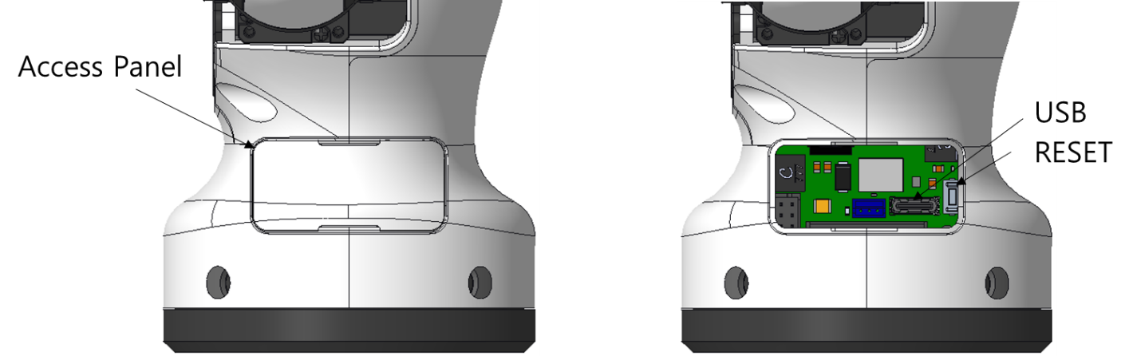

Access using a Firmware Update Tool with the following settings.
- Click “Refresh” Button & Select correct Serial Port.
- Baud Rate: 921,600
- Click “Open Port” Button.
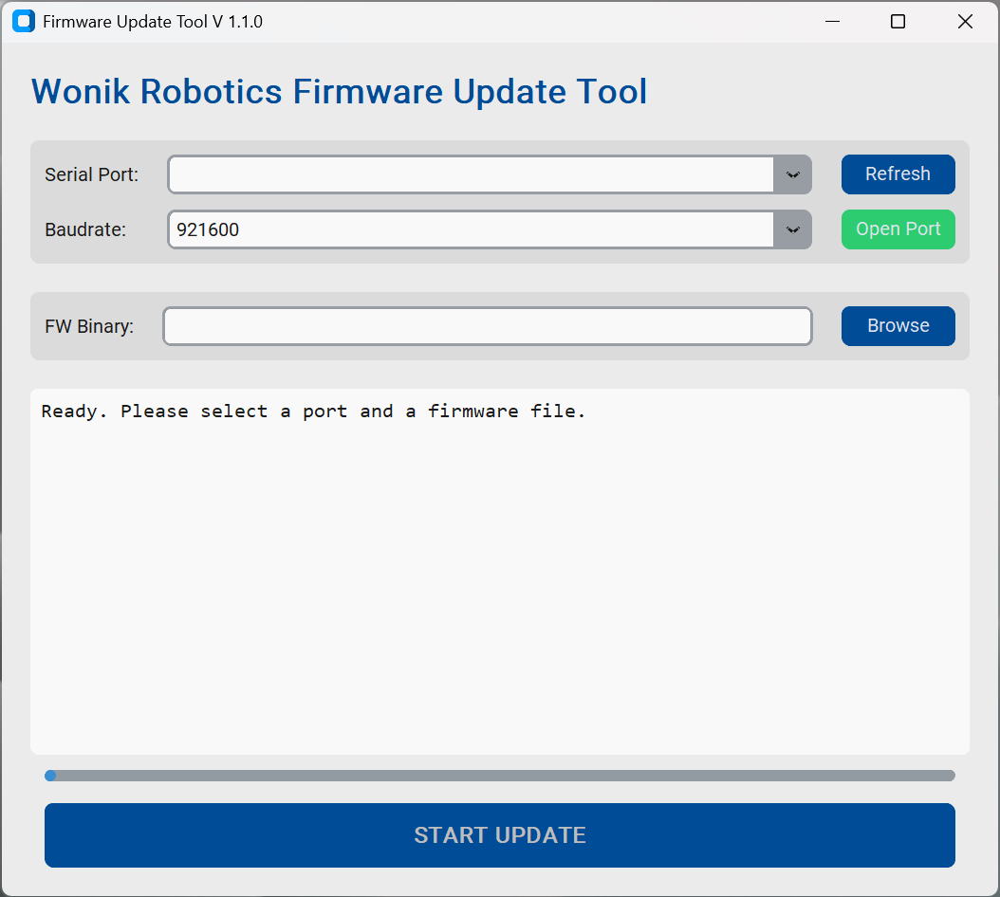

14.2.2 Run the Application
After connecting to the Serial Port, browse the FW Binary File.
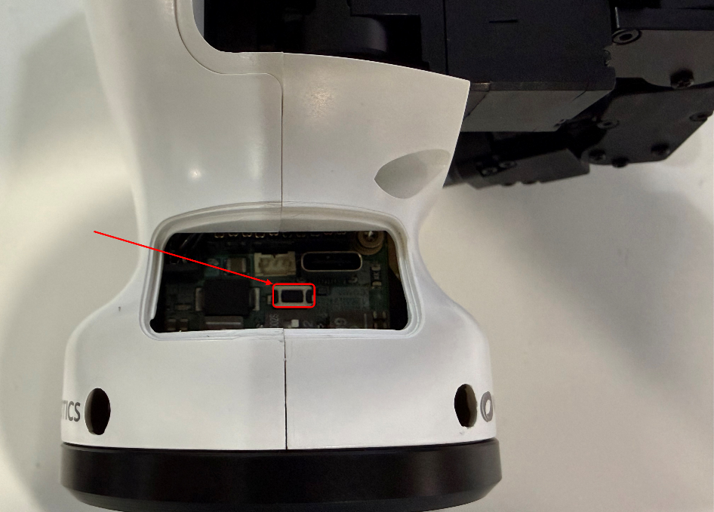
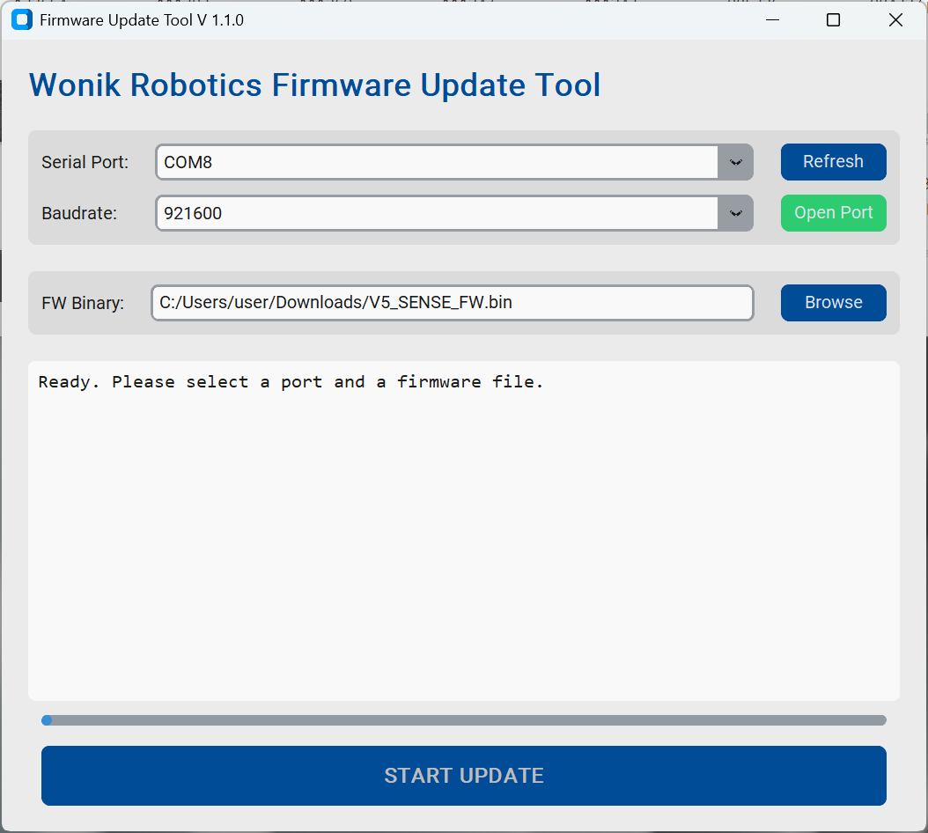
- Click “START UPDATE” Button.

- Click “RESET” Button on the side of the Allegro Hand.
- Then the program will start updating Firmware automatically
15. Technical Support
The newest version of all documents found in this manual can be found in the Allegro Hand website at
https://www.allegrohand.com/
A forum is also available on the website where users can share problems and solutions with each other and with WONIK ROBOTICS.
For any further questions please contact us.
Address | Wonik Bldg. 4F, 20, Pangyo-ro 255beon-gil, Bundang-gu, Seongnam-si, Gyeonggi-do, Republic of Korea
Phone | +82-31-8038-9180
Fax | +82-31-8038-9190
Email | robotics.biz@wonik.com

16. FAQ
16.1 Hardware FAQ
- CAD STL Files
If you purchase, we will provide STL files.
Please give us your Hand’s serial number.

- Communication interface
CAN / Ethernet(UDP) communication is supported.

- CAN Device purchase
We usually recommend the PEAK device.
Model: PCAN-USB (IPEH-002021 or IPEH-002022)

Wonik Robotics does not sell CAN equipment.

- Fingertip sensor
The contact surface of the fingertip sensor is made of silicone, and it operates by measuring internal air pressure. If it is punctured by sharp objects such as an awl or knife, internal air may leak, which can cause malfunction.

- How robust is it to collisions?
Difficult to use in harsh environments.
It should be noted that this is for research purposes only.
Please avoid hitting a hammer or applying any excessive force.
- Range of motion

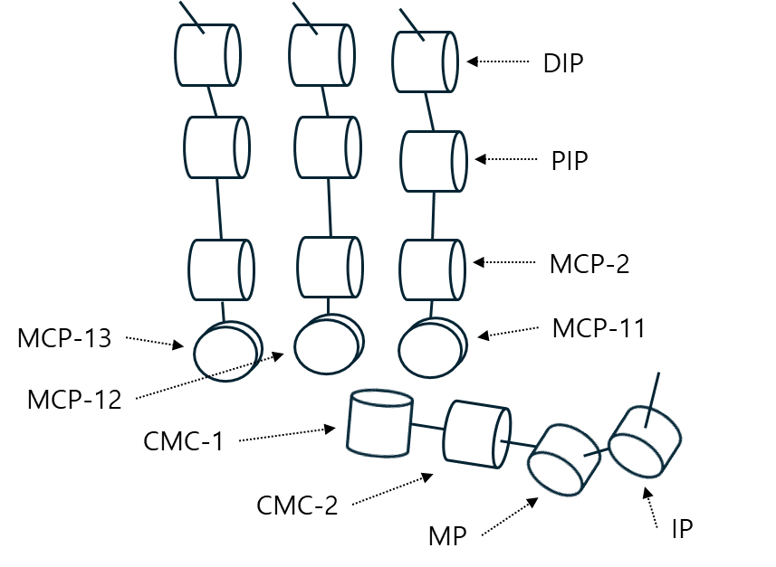

 | Joint | ROM [deg]
Finger | MCP-11 | -40 ~ 15
Finger | MCP-12 | -15 ~ 15
Finger | MCP-13 | -15 ~ 40
Finger | MCP-2 | -5 ~ 100
Finger | PIP | -5 ~ 107
Finger | DIP | -5 ~ 107
Thumb | CMC-1 | 0 ~ 100
Thumb | CMC-2 | -15 ~ 100
Thumb | MP | -3 ~ 106
Thumb | IP | -5 ~ 103

- CAN wiring
If you want to use CAN communication with the PCAN-USB, connect it to the D-SUB connector as shown in the picture below. Connect the green wire (CAN L) to pin 2 and the yellow wire (CAN H) to pin 7.

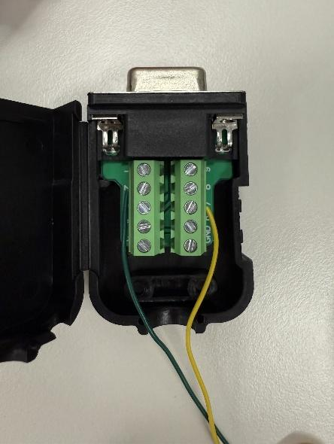

16.2 Software FAQ
- Is it possible to use V4 or V5_Plus software?
No.
There are many differences between V5_Sense and previous versions.

- How are the joints controlled?
It is controlled by CAN communication with the external controller and UART communication between the joint(16ea) and the main board inside the hand. The only motor control command is the “Set Torque Finger” command.
The unit of Torque data is [mA]. It is the value obtained by converting joint torque into current for motor operation.

- Is PID position control possible?
Since the main board only can “Torque” control, position control works are required on the PC side. “Home” motion is playing such a role. The joint position encoder value is needed.
If you want to perform PID position control, you will need to configure the controller yourself. However, since the main board only provides joint position encoder values, precise control may be challenging. Please check the control frequency.

- How to set (left or right) of hand in SW?
Software automatically applies to the appropriate handedness and hand type through the serial number. Therefore, you can simply use it as is.

- How can I use H-infinity Mode?
To use the onboard H-infinity position control mode, you must first enable it by sending the HINF_MODE command with data[0] = 1. Once enabled, the firmware's internal position loop takes over. You can then command joint positions by sending the Set Pose Direct Finger commands where the position targets are 2-byte signed integers (encoder counts).
To disable H-infinity mode and return to the default Torque Control mode, send the HINF_MODE command with data[0] = 0.
If you are using the provided ROS2 driver, simply launch the node with the argument HINF_MODE:=true. The driver will automatically send the enable command during initialization and published joint targets to the 'allegroHand/joint_cmd' topic into Set Pose Direct Finger CAN frames/UDP Packets.
.
- Where can PC S/W issues be supported?
You can use our official Forum: https://www.allegrohand.com/forum
Or you can check our official GitHub latest release, see the link below.
https://github.com/Wonikrobotics-git

Release Note
Date | Ver. | Description | Editor
2026.05.21 | 1.0 | Initial draft | Lucas
2026.05.22 | 1.1 | Add a method of switching com mode | Hibo

